26.36: An uncharged capacitor is placed into a circuit.
a) At the instant the circuit is completed, there is no voltage over the capacitor, since it has no charge stored.
b) All the voltage of the battery is lost over the resistor, so 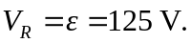
c) There is no charge on the capacitor.
d) The current through the resistor is 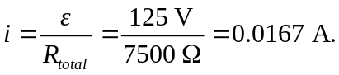
e) After a long time has passed:
The voltage over the capacitor balances the emf: 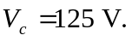
The voltage over the resister is zero.
The capacitor’s charge is
The current in the circuit is zero.

